SRS - AUA Rentals Vehicle Rental System v2.0
Oct 31, 2026 · @Ashar

Revision history and change log
Version 2.0 records three changes to AUA Rentals OOP.cpp: CH-02 and CH-03 are done for normal use, and CH-01 covers the View Rented screen only.
Version | Date | Summary
1.0 | 25 Oct 2026 | First SRS, reverse-engineered from the fixed car_rental.cpp.
2.0 | 31 Oct 2026 | Re-baselined on AUA Rentals OOP.cpp; adds CH-01 to CH-03 and a status column for every requirement.

ID | Change: before, then after | Code location | Requirements | Status in v2.0
CH-01 | Customer saw another customer's rented vehicle. Before: rented-vehicle screens scanned other customers' rentals (v1.0 defect 7). After: View Rented Vehicles reads only the logged-in customer's row, cusRentedVehicle[foundIndex][m][n]. | Rent::rentDetails, menu option 2, line 764 | FR-RNT-05, UR-03 | Partly done. Return Vehicle (line 797) still loops over every customer.
CH-02 | A rented car could be rented by a second customer. Before: an already-rented vehicle number could be accepted. After: the rent flow looks the vehicle up by identification number, checks isVehAvailable, and for a rented one prints VEHICLE ALREADY RENTED and returns to the rent menu. A customer already holding a vehicle is refused earlier, on isCusAvailable (line 651). | Rent::rentDetails, menu option 1, lines 651 and 704 to 712 | FR-RNT-03, FR-RNT-04, NFR-03 | Done for normal use. Depends on recursive menu returns (limitation L-01).
CH-03 | Letters at a menu prompt caused an infinite loop. Before: cin>>option failed, stayed in a fail state and re-read the same bad input forever. After: every menu prompt tests if(!(cin>>option)), then calls cin.clear() and cin.ignore(1000, '\n'), prints INVALID INPUT and redisplays the menu. | Nine menu prompts: lines 285, 392, 495, 639, 885, 939, 1007, 1068, 1219 | FR-INP-01, FR-INP-02, NFR-02 | Done for menu prompts. Not yet for mileage, rent per km, return mileage, Y/N prompts or closed input (L-02).

1. Introduction
AUA Rentals is a C++ console program in which owners list vehicles, customers rent them by the kilometre, and an admin oversees users, vehicles and revenue; this SRS states what the current code does and how far it meets each requirement.

1.1 Purpose
To give developers, testers and the course instructor one agreed description of the system, so the code in AUA Rentals OOP.cpp can be checked against it requirement by requirement.

1.2 Scope
A single-machine, text-menu program. Owners register and list up to 3 vehicles each. Customers register, rent one vehicle at a time and return it for a per-kilometre charge. The admin views customers, owners, vehicles and total revenue. Data lives in plain text files. Online payment, GPS tracking, booking by date and a graphical interface are out of scope.

1.3 Definitions
Term | Meaning
Customer | A registered person who rents a vehicle
Owner | A registered person who lists vehicles for rent
Admin | The single built-in manager account
Mileage | The vehicle's odometer reading in km
Rent per km | The charge in RS for each km driven during a rental
Rental cost | (return mileage - mileage at pickup) x rent per km
Revenue | Sum of all rental costs collected since the data files were created
Met / Partly met / Not met | How far AUA Rentals OOP.cpp meets a requirement today (section 4)

1.4 References
- IEEE Std 830-1998, Recommended Practice for Software Requirements Specifications
- Source file AUA Rentals OOP.cpp (1,528 lines, C++11, standard library only)
- SRS - AUA Rentals Vehicle Rental System, version 1.0, 25 Oct 2026

2. Overall description
The product is one standalone program with three portals behind a main menu, all sharing one in-memory data set that is saved to text files.

2.1 Product perspective
No network, database or third-party library. At start-up loadAllData() reads five text files; saveAllData() writes seven after every change. Global arrays hold the data, four classes hold the behaviour (loginAccess, Register, Management, Rent), and free functions draw the menus, which call one another recursively.

2.2 User classes
User | Entry point | Main goals
Customer | Customer portal | Register, log in, rent one vehicle, view it, return it and see the cost
Owner | Owner portal | Register, log in, add up to 3 vehicles, view and remove them
Admin | Admin portal (admin / admin123) | Review customers, owners, vehicles (all, available, rented) and total revenue

2.3 Operating environment
Any OS with a C++11 compiler, a console, and write access to the folder the program runs from.

2.4 Design and implementation constraints
- Fixed global arrays: 10 customers, 10 owners (MAX_USERS) and 3 vehicles per owner (the 3 is written directly into the code).
- Text-file persistence with | as the field separator; the code does not yet reject | in typed text.
- Console only; numbered menus; the screen is "cleared" by printing 25 blank lines.

2.5 Assumptions and dependencies
- One program instance uses the data files at a time.
- Customers are trusted to enter the true odometer reading on return.
- Currency is RS (rupees).

3. Requirements engineering
The v1.0 requirement set is kept, and version 2.0 adds a check of each requirement against the current code, so the document shows what the program does, not what it should do.

3.1 Process followed
Stage | What was done in v2.0
Elicitation | The developer reported three fixes (CH-01 to CH-03); every menu, prompt and message in the source was read again.
Analysis | Each fix was mapped to the requirement it serves, and each requirement was traced to the lines that implement it.
Specification | IDs (UR, FR, NFR) and priorities are unchanged from v1.0; a status column was added.
Validation | Code inspection of each changed line and its neighbours; results are in section 7. Scripted runs are listed as future work.
Management | IDs are stable, so a change request can cite them; the tables in section 4 are the traceability matrix.

3.2 Stakeholders
Stakeholder | Interest
Customer | Easy registration, clear price, quick rent and return, no view of other customers' rentals
Owner | Control over which vehicles are listed, correct payment for km driven
Admin | A complete, accurate view of users, fleet and revenue
Developer and instructor | A system that is testable, readable and traceable to requirements

4. Requirements and status in v2.0
Of the 38 functional requirements, 22 are met, 10 are partly met and 6 are not met by AUA Rentals OOP.cpp; the status column is new in version 2.0.
Met: works as specified, by the scripted run or by inspecting the lines. Partly met: the main case works but a stated condition fails. Not met: no code for it yet.
Group | Total | Met | Partly met | Not met
User requirements (UR) | 11 | 8 | 3 | 0
Functional requirements (FR) | 38 | 22 | 10 | 6
Non-functional requirements (NFR) | 9 | 5 | 4 | 0
All requirements | 58 | 35 | 17 | 6

4.1 User requirements
ID | As a ... I want to ... | Priority | Status
UR-01 | customer, register and log in with my email and password | Must | Met
UR-02 | customer, see which vehicles are free and their rate per km | Must | Met
UR-03 | customer, rent a free vehicle and later return it and see my cost | Must | Met
UR-04 | owner, register and log in | Must | Met
UR-05 | owner, add, view and remove my vehicles | Must | Partly met
UR-06 | admin, log in to a protected portal | Must | Met
UR-07 | admin, list and search customers and owners | Should | Partly met
UR-08 | admin, see all, available and rented vehicles | Should | Met
UR-09 | admin, see total revenue | Should | Met
UR-10 | any user, keep my data after the program closes | Must | Met
UR-11 | any user, get a clear message when I enter bad input | Should | Partly met

4.2 Registration and login
ID | Requirement | Priority | Status | Evidence and note
FRREG-01 | Register a customer or an owner from name, phone, email and password with the next sequential ID. | Must | Met | Register::registerCus, registerOwn
FRREG-02 | Reject a registration whose email already exists in the same user class. | Must | Met | Also rejects a repeated name (v1.0 defect 14, open).
FRREG-03 | Reject empty fields, fields containing |, malformed emails and phones not 7 to 15 digits, + or -. | Should | Not met | No field validation in the register functions.
FRREG-04 | Store at most 10 customers and 10 owners and say so at the limit. | Must | Met | MAX_USERS check at the top of each register function.
FRREG-05 | Use the lowercased email as the username. | Must | Partly met | Email is the username but is not lowercased, so login is case-sensitive.
FRAUT-01 | Grant customer access only when email and password match; otherwise print ACCESS DENIED. | Must | Met | loginAccess::verifyCustomer
FRAUT-02 | Do the same for owners. | Must | Met | loginAccess::verifyOwner
FRAUT-03 | Grant admin access only for the built-in admin credentials. | Must | Met | loginAccess::verifyAdmin

4.3 Owner and vehicle management
ID | Requirement | Priority | Status | Evidence and note
FR-OWN01 | An owner adds a vehicle with name, identification number, mileage and rent per km; the ID is owner number plus sequence, such as 1-2. | Must | Met | Register::registerVehicle; IDs 1-1 and 1-2 seen in the run.
FR-OWN02 | At most 3 vehicles per owner. | Must | Partly met | Limit works, but the message branch opens the customer portal with an owner index (line 229, v1.0 defect 5).
FR-OWN03 | Vehicle identification numbers are unique across all owners; re-ask on a duplicate. | Must | Not met | The duplicate loop compares the wrong arrays (lines 242 to 253, defect 4).
FR-OWN04 | Accept mileage of 0 or more and rent per km above 0 only. | Must | Not met | Values read with cin>> into float, unchecked.
FR-OWN05 | An owner views profile, vehicle count and each vehicle with its status. | Must | Met | ownPortal, option 1
FR-OWN06 | An owner removes a vehicle after a Y/N confirmation. | Must | Partly met | Confirmation works; an unknown number carries on with index -1 (line 1141, defect 10).
FR-OWN07 | Refuse to remove a rented vehicle. | Must | Not met | No rented check before deletion (defect 11).
FR-OWN08 | After a removal, renumber the remaining vehicle IDs and keep their rentals attached. | Should | Not met | IDs and cusRentedVehicle are not shifted (defect 11).

4.4 Renting and returning
ID | Requirement | Priority | Status | Evidence and note
FR-RNT01 | A logged-in customer sees their profile and whether they hold a vehicle. | Must | Met | cusPortal
FR-RNT02 | List only vehicles that are not rented, with owner, ID, name, number, mileage and rate. | Must | Partly met | Lists unrented vehicles with all fields except the owner's name.
FR-RNT03 | Rent a vehicle by identification number after a Y/N confirmation; a rented or unknown number is refused. | Must | Met | CH-02. Run: Bilal typing ABC-1 while Ali held it got VEHICLE ALREADY RENTED.
FR-RNT04 | A customer holds at most one rented vehicle at a time. | Must | Met | isCusAvailable check at line 651.
FR-RNT05 | A customer views only their own rented vehicle. | Must | Partly met | CH-01. View Rented is fixed (run: Bilal saw only his own). Return Vehicle (line 797) still lists every customer's rentals (run: Bilal was offered Ali's ABC-1).
FR-RNT06 | On return the customer enters the odometer reading; a reading below the stored mileage is refused. | Must | Met | Lines 815 to 819.
FR-RNT07 | Cost = (new mileage - old mileage) x rent per km; show it, add it to revenue, store the new mileage, free vehicle and customer. | Must | Met | Lines 821 to 830.
FR-RNT08 | A customer can cancel a return and keep the vehicle rented. | Should | Met | Run: answering n printed RETURN VEHICLE CANCELLED.

4.5 Administration
ID | Requirement | Priority | Status | Evidence and note
FRADM-01 | List all customers with ID, name, phone, email and rental status. | Should | Met | Management::cusManagement, option 1
FRADM02 | Register a customer or an owner from the admin portal. | Could | Met | Options 2 of both management menus.
FRADM-03 | Search a customer or an owner by email. | Should | Partly met | A found record prints, but NOT FOUND is printed after the menu returns (lines 360 to 365, defect 9).
FRADM04 | List all owners with their vehicle counts. | Should | Partly met | Lists owners; the vehicle count is not shown.
FRADM-05 | List all, only available, or only rented vehicles. | Should | Met | Management::vehManagement; the rented list prints RENTED correctly.
FRADM-06 | Show total revenue in RS. | Should | Met | Management::transManagement

4.6 Persistence and input handling
ID | Requirement | Priority | Status | Evidence and note
FR-PER01 | Load customers, owners, vehicles, revenue and active rentals from text files at start-up. | Must | Met | loadAllData
FR-PER02 | Save after every change and on exit. | Must | Met | saveAllData after each register, rent, return, delete and exit.
FR-PER03 | After a restart, rented vehicles and their customers still show as rented. | Must | Met | RENT_DETAILS.txt is read back at start-up.
FR-PER04 | Write report files of available and rented vehicles. | Could | Met | AVAILABLE_VEH_DATA.txt, RENTED_VEH_DATA.txt
FR-PER05 | Skip malformed lines in data files instead of crashing. | Should | Partly met | Incomplete lines stop the read; stoi and stof have no try/catch, so a bad number would throw.
FR-INP01 | Reject a non-numeric menu or number entry and ask again. | Should | Partly met | CH-03. Nine menu prompts guarded (run: abc gave one INVALID INPUT and a redisplay). Mileage, rate, return mileage and Y/N prompts are unguarded.
FR-INP02 | Show a message for a choice outside the list and redisplay the menu. | Should | Partly met | Message shown, but the rent menu sends an invalid choice to the customer portal (line 852) and the owner portal to the owner menu (line 1200).
FR-INP03 | Back and Exit return to the previous menu; the program ends only from main menu option 4, and saves and ends if input is closed. | Must | Not met | Menus call each other. Run: after PROGRAM ENDED an earlier Return prompt reappeared, and at end of input the program crashed (exit code 139).

4.7 Non-functional requirements
ID | Category | Requirement | Status | Evidence and note
NFR-01 | Usability | Every screen is a numbered menu with a prompt; messages are plain capitals text. | Met | All menus.
NFR-02 | Reliability | Bad input never crashes the program or loops forever. | Partly met | Fixed for menu prompts (CH-03); unguarded numeric prompts and end of input still fail (L-02).
NFR-03 | Data integrity | A vehicle is never rented to two customers and a customer never holds two vehicles. | Partly met | Enforced at the prompt (CH-02, FR-RNT04). Stale menu frames can resume after Exit (L-01), so "never" is not yet proven.
NFR-04 | Persistence | Data survives a normal exit and a closed input stream. | Met | Data is saved after every change, so the crash at end of input loses nothing.
NFR-05 | Performance | Every action responds instantly for 10 customers, 10 owners and 30 vehicles. | Met | Loops over at most 10 x 10 x 3 entries.
NFR-06 | Portability | Builds with any C++11 compiler using only the standard library. | Met | Compiled with g++ -std=c++11 -Wall -Wextra, no warnings.
NFR-07 | Maintainability | Four classes plus helper functions; menus use loops, not recursion. | Partly met | Four classes exist; every menu is recursive.
NFR-08 | Security (basic) | Portals require credentials; passwords are stored as plain text. | Met | See limitations, section 8.
NFR-09 | Capacity | 10 customers, 10 owners, 3 vehicles per owner, set by named constants. | Partly met | MAX_USERS exists; the 3 vehicles per owner is a literal in the code.

5. Interfaces, data files and business rules
The program talks to the user through the console and to disk through seven text files in its working folder.

5.1 External interfaces
- User interface: keyboard input and text output in a console; menu choices are read with cin>> and names, emails, passwords and vehicle numbers with getline.
- File interface: plain text files read at start-up and rewritten after every change.
- Hardware and network: none.

5.2 Data files
File | Content, one record per line (fields split by |) | Read back
CUSTOMERS_DATA.txt | id, name, phone, email, username, password, renting flag | Yes
OWNERS_DATA.txt | id, name, phone, email, username, password | Yes
VEHICLES_DATA.txt | owner index, vehicle ID, name, number, mileage, rate per km, rented flag | Yes
RENT_DETAILS.txt | customer index, owner index, vehicle index, then a readable copy of customer, owner and vehicle details | Yes
REVENUE.txt | total revenue | Yes
AVAILABLE_VEH_DATA.txt, RENTED_VEH_DATA.txt | report files for humans | No
Naming note: the flags isVehAvailable and isCusAvailable are true when a vehicle is rented and when a customer holds one, the opposite of what the names suggest (v1.0 defect 15, open).

5.3 Business rules
- BR-01: Rental cost = (return mileage - pickup mileage) x rent per km, so no cost accrues without driven distance.
- BR-02: All rental cost is credited to total revenue and paid to the owner at return.
- BR-03: The return mileage becomes the vehicle's new pickup mileage.
- BR-04 (new in v2.0): A rented vehicle cannot be rented again until it is returned (CH-02).

6. UML models
Three diagrams are new or redrawn for version 2.0; the use case diagram (v1.0 section 6.1) and domain model (v1.0 section 6.3) are unchanged and still valid.

6.1 Class diagram: code structure
Menu functions create the four classes on demand; every class reads and writes the shared global arrays, and saveAllData() and loadAllData() move them to and from the text files. The red tags mark where CH-01 to CH-03 landed.
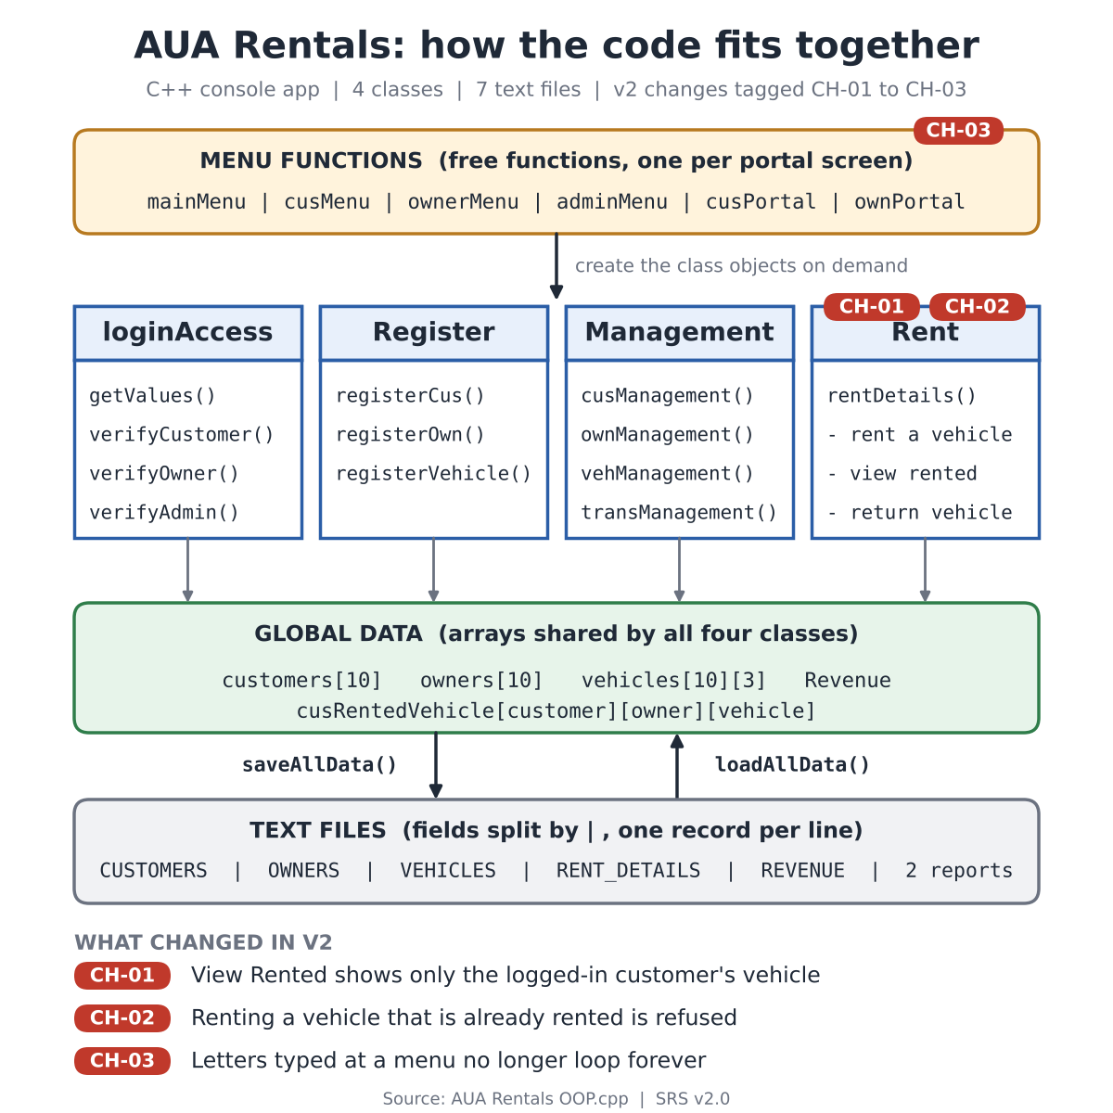

6.2 Sequence diagram: rent a vehicle
Step 7 is the CH-02 guard: a vehicle whose isVehAvailable flag is already true is refused before any data changes.
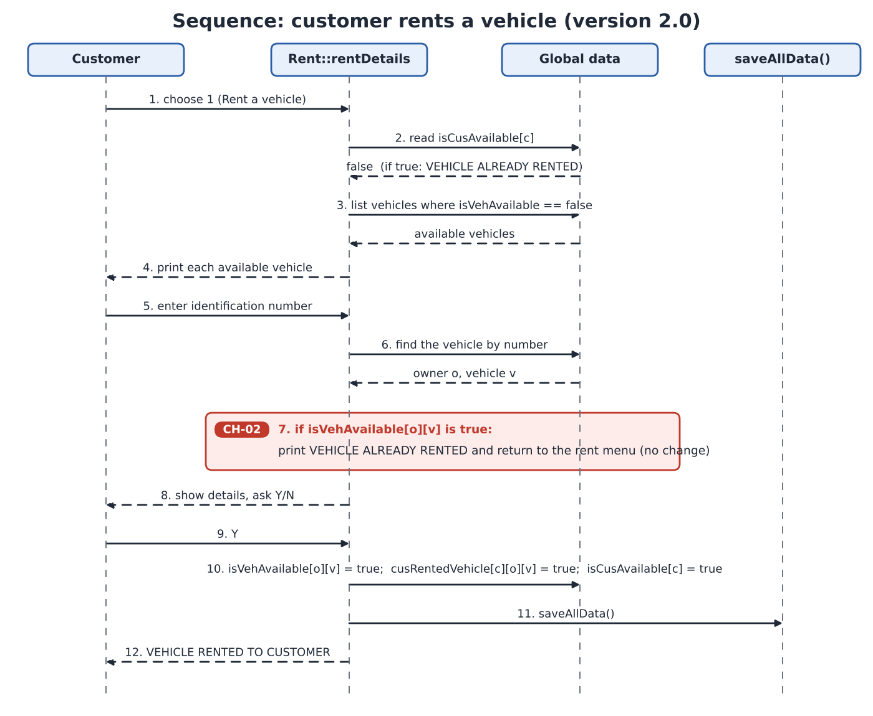

6.3 State diagram: vehicle
A vehicle moves between Available and Rented only through rent and return. The dashed red arrow is a gap, not a design: Remove does not check the rented flag yet (L-05).
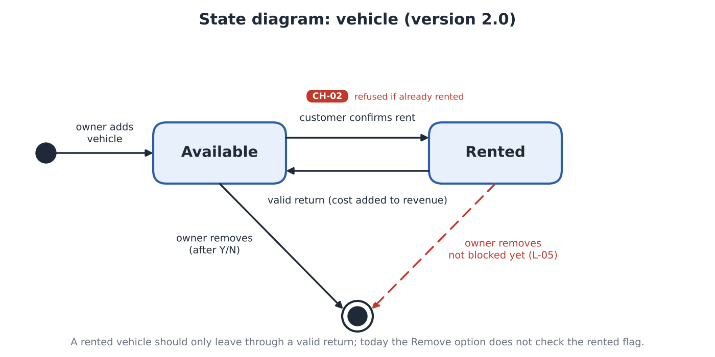

7. Verification
The three changes were checked by one scripted console session on 31 Oct 2026: CH-02 and CH-03 passed, CH-01 passed on View Rented and failed on Return Vehicle.
The file builds with g++ -std=c++11 -Wall -Wextra and no warnings. Input was piped to the program in one run with two customers (Ali, Bilal), one owner and two vehicles (ABC-1, XYZ-2).

7.1 Test results
Test | Expected | Result
Ali rents ABC-1, then Bilal enters ABC-1 | Refused | Pass: VEHICLE ALREADY RENTED (CH-02)
Bilal opens View Rented while Ali holds a vehicle | Bilal sees none of Ali's | Pass: NO VEHICLES RENTED (CH-01)
Bilal holds XYZ-2 and opens Return Vehicle | Only Bilal's vehicle | Fail: Ali's ABC-1 is offered first (CH-01 still open)
Type abc at a menu prompt | One error message, menu redisplayed | Pass (CH-03)
Start a return, then answer n | Vehicle stays rented | Pass
Choose Exit from the main menu | Program ends | Fail: earlier Return prompts reappear after PROGRAM ENDED (L-01)
Input ends while a menu is waiting | Data saved, program ends | Fail: crash, exit code 139 (L-02); data was already saved
Register a customer after an owner has added vehicles | Owner's vehicle count unchanged | Fail: the owner's 2 vehicles disappeared (line 165, defect 3)

7.2 Status of the 15 defects from version 1.0
Three of the 15 defects are fixed or partly fixed by CH-01 to CH-03, one is not present in this file, and 11 remain open.
# | Defect in v1.0 | Status in v2.0
1 | Menus call each other recursively; Exit unwinds old menus | Open (seen in the run)
2 | Letters at a number prompt cause an endless loop | Partly fixed: menu prompts (CH-03)
3 | Registering a customer erases an owner's vehicle count | Open (seen in the run)
4 | Duplicate vehicle-number check compares the wrong arrays | Open
5 | Maximum-vehicles message opens the customer portal | Open
6 | A rented vehicle could be rented again | Fixed for normal use (CH-02)
7 | Rented-vehicle screens show other customers' rentals | Partly fixed: View Rented (CH-01); Return open
8 | Admin rented list printed NOT RENTED | Not present: the list prints RENTED
9 | Search prints NOT FOUND after the menu returns | Open
10 | Removing an unknown number uses index -1 | Open
11 | A rented vehicle can be removed; IDs repeat after a removal | Open
12 | Invalid choice or Exit jumps to the wrong menu | Open
13 | float values, negatives and | in text accepted | Open
14 | Two customers with the same name cannot both register | Open
15 | ALL DATA SAVED after every change; misleading flag names | Open

8. Known limitations and next steps
The most urgent gaps are L-03 and L-04, because each lets one user's data affect another's, followed by L-01 and L-02, which cause the crashes seen in the run.
ID | Limitation | Why it matters | Suggested next step
L-03 | Return Vehicle loops over every customer (line 797); it and View Rented bound the owner loop by totalVehicles (lines 760, 793), not totalOwners | A customer is offered, and could return, another customer's vehicle | Scan only cusRentedVehicle[foundIndex][b][c], with b up to totalOwners
L-04 | Registering a customer sets vehPerOwn[totalCustomers]=0 (line 165) | An owner with the same index loses all vehicles from the count | Delete that line
L-01 | Menus call each other recursively | Exit unwinds old menus; earlier prompts reappear after PROGRAM ENDED | Turn each menu into a loop that returns to its caller
L-02 | Mileage, rate, return-mileage and Y/N prompts are unguarded, and end of input is not handled | Bad input breaks cin; at end of input the menu guard recurses until the program crashes | Read whole lines and parse them; save and exit when cin.eof()
L-05 | A rented vehicle can be removed by its owner | A rental is left pointing at nothing | Refuse removal while rented; renumber IDs and rental flags after a removal
L-06 | Passwords are stored as plain text and the admin login is fixed in the source | Anyone who can open the data files can read every password | Store salted hashes; read admin credentials from a file
L-07 | Arrays are fixed at 10 customers, 10 owners and 3 vehicles per owner | The system cannot grow | Replace arrays with structs in std::vector, keeping the same menus
L-08 | One rental at a time, no booking dates, only a running revenue total | No reservations, receipts or per-owner earnings | Add start and end dates and append each rental to a history file
L-09 | Tests are manual, scripted sessions | Regressions can slip in | Add an automated script that pipes input and compares output

